**CS673F13 Software Engineering**

**Group Project 3 - Edu kid**

**Software Design Document**

|  |  |  |  |
| --- | --- | --- | --- |
| Team Member | Role(s) | Signature | Date |
| Kevin Graue | Leader, Environment and Integration Leader | *kevin grague* | 11/28/2013 |
| Sweekriti Satpathy | Co-Design Leader | *sweekriti satpathy* | 11/28/2013 |
| Sandeep Nukala | Configuration leader | *sandeep nakula* | 11/28/2013 |
| Isha Rana | Quality Assurance Leader | *isha rana* | 11/28/2013 |
| Rakshit Sachdev | Co-Design Leader | *rakshit sachdev* | 11/28/2013 |
| Jasjot Singh | Implementation Leader | *jasjot singh* | 11/28/2013 |
| Peter Trevino | Backup team Leader, Requirement leader | *peter trevino* | 11/28/2013 |
| Chitra Premkumar | Quality Assurance Leader | *chitra premkumar* | 11/28/2013 |

**Revision history**

|  |  |  |  |
| --- | --- | --- | --- |
| **Version** | **Author** | **Date** | **Change** |
| 1.1 | Isha Rana | 10/17/2013 | Initial creation |
| 1.1 | Chitra Premkumar | 12/07/2013 | Software Architecture |
| 1.2 | Isha Rana | 11/28/2013 | Final closure |

* Introduction
* Software Architecture
* Design Patterns
* Classes and Methods
* References

# Introduction

EDUkid is an Android App, to be used primarily on the tablet. Our mission is: "Delight children through learning." The motivation of this app to create an application which not only allows children to learn in a fun and interactive way, but to also allow parents to be involved in the project. We want to allow parents to be able to customize the content as per their requirement and needs of their child.

Our main purpose is to help making learning more enjoyable for the child and also integrate the current world advancement of technology of tablets into children’s education field.

We aim to make this app available for children in the age group of 5 and above and for their parents.

**Two modes:**

* Learning mode
* Game mode

**EDUkid is an Android Application to help children learn**

* Supports Letters, Numbers, Colors, and Shapes out of the box
* Each category allows the parent to upload custom pictures for letters, words, shapes, etc. to personalize the learning
* Allows for custom learning module creation

We areable to achieve what all we intented to in the beginning, including the game mode and all the customization features.A game mode to test the child’s success

A summary page for parents to view their child’s success, and any areas that may require additional attention.

* We strive to give children just the right balance between education and fun. So our games don't feature fun at the expense of education – or education at the expense of fun. We also know games that are too complicated don’t involve and delight kids.
* We have included features like customizable menus, play-timer which makes this app a complete delight for parents allowing them to control the usage time of their children

# Software Architecture

As we created an android app we followed the following architecture.

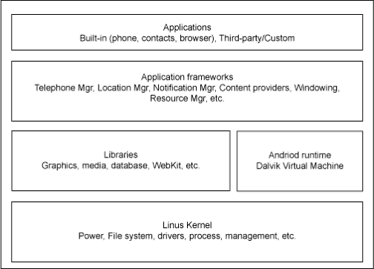

Our project can be explained on the basis of following use case diagrams:

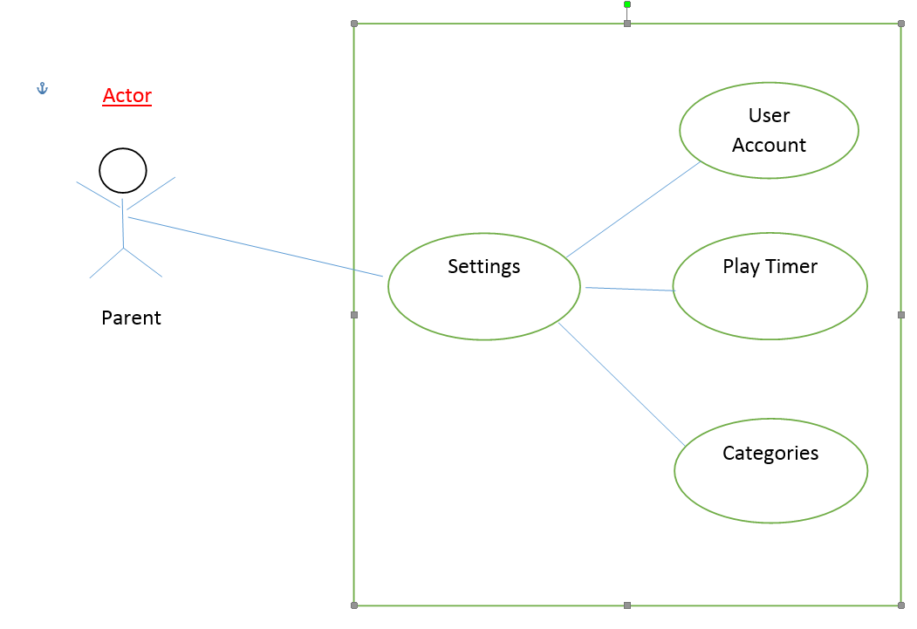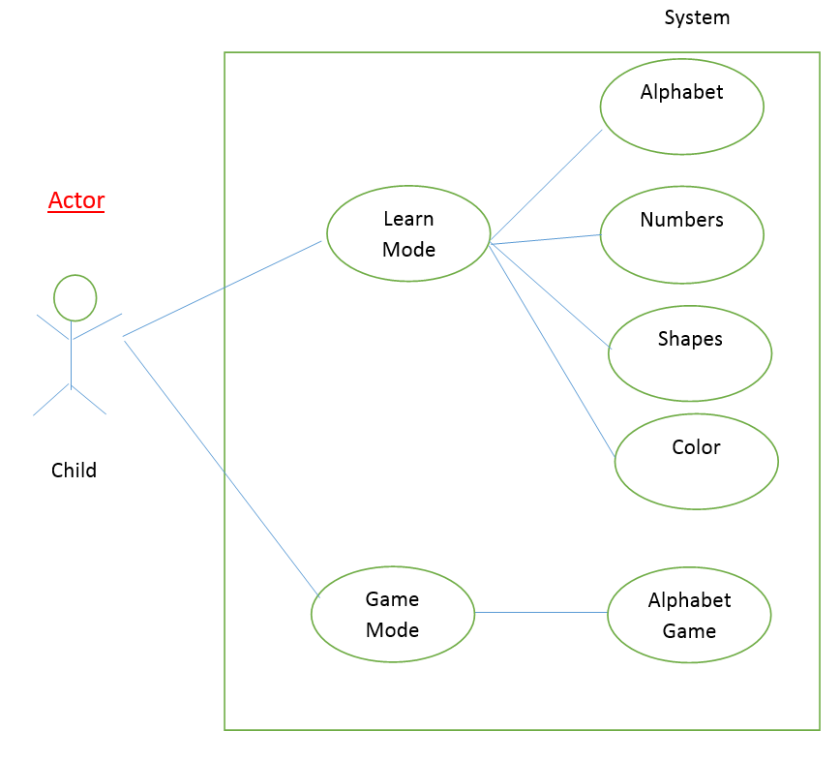

# Design Patterns

# Our project follows MVC i.e we have a model,view and control .

**Standard Java coding practice**

* + Camel case for variables (example: thisIsAnExampleVarible)
  + Class names always start capitalized (example: ExampleClass.java)
* Root package: bu.edu.cs673.edukid
* Use standard Eclipse code formatter before code commits

**Android Applications Divided into 2 Parts:**

* Functionality Controlled by Java Files
* User Interface Controlled by XML Files

**In our Application**

* We have XML Pages for Each Section
  + Splash Screen
  + Main Page
  + Game Page
  + Learn Page
  + Settings Page

**Implementation Of SQLite In Android SDK**

* Model - Class declaration of each table
* Views - XML files for each screen for data display
* Control - Database.java and databaseHelper.java that contains the function

# **Classes and methods**

For user account we have :

* Column_user_id(primary key)-Assigns a unique id to each user
* Column_user_name-The name of the user
* Column_user_iamge-The image taken of the user through the camera app
* Column_user_sound-name of the user is recorded while signing up or else text to speech is used to determining the sound.

# For letters we have

# column_letter_id(primary key)-Assigns a unique id to each letter from a to z

* column_letter_word-This is the letter itself
* column_letter_sound-The sound of each letter

For words we have

* Lid( foreign key)-This refers to the letter id in the letters table
* Tid( foreign key)-This refers to the theme id in the theme table
* Word-Different word corresponding to the letters
* Wordsound-Sound for the different words using text to speech
* Wordimage-The images for each word
* Wordschecked – Visibility of the word determines by value 0 and 1

For word map we have

* defaultwordmapcategoryid –This refers to the category id
* defaultwordmapitemid – Default database item
* defaultwordmapwordid – default database words of the corresponding default database item.
* defaultwordmapchecked – default database checked of the corresponding default database item.

For table timer we have

* table_timer – Game timer
* expired - Boolean value set to true if the timer expires
* enabled – Boolean value set to true if the timer enabled
* Learntime – parents enable for child to play

# References